Tostones or Fried Plantains of Puerto Rico
5 Tablespoons of oil for frying (Vegetable oil works well)
Green Plantains
- Peel the plantain and cut it into 1-inch chunks.
- Heat the oil in a large skillet. Place the plantains in the oil and fry on both sides, approximately 3 1/2 minutes per side.
- Remove the plantains from the pan and flatten the plantains by placing a plate over the fried plantains and pressing down.
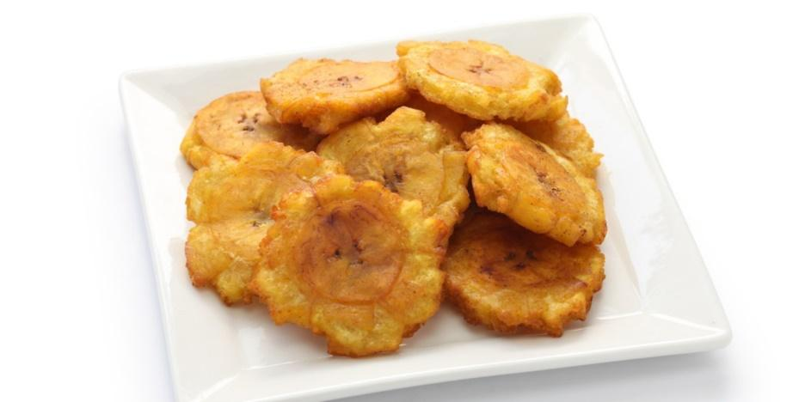
- Dip the plantains in water, then return them to the hot oil and fry 1 minute on each side. Salt to taste and serve immediately.

